RESOLUTION OF THE BOARD OF DIRECTORS OF THE FALLBROOK VILLAS METROPOLITAN DISTRICT
TO ADOPT

CONDUCT OF MEETINGS POLICY

WHEREAS, the Fallbrook Villas Metropolitan District (“District”) is a quasi-municipal corporation and political subdivision of the State of Colorado; and

WHEREAS, pursuant to Colorado Revised Statutes §32-1-1001(1)(h), the Board of Directors (“Board”) of the District is empowered to have the management, control and supervision of all of the business and affairs of the District; and

WHEREAS, pursuant to Colorado Revised Statutes §32-1-1001(1)(m), the District has the power to adopt, amend, and enforce bylaws and rules and regulations not in conflict with the Colorado Constitution for the purpose of carrying on the business, objects, and affairs of the Board and the District; and

WHEREAS, the Board desires to adopt a policy regarding the conduct of all regular and special meetings in order to efficiently and effectively hold such meetings.

NOW THEREFORE, the Board hereby adopts the following policy for conduct of meetings, pursuant to Colorado statutes, which policy supersedes all policies and procedures regarding conduct of meetings adopted prior to its effective date.

BOARD MEETINGS

- Meetings of the Board of Directors shall be held at such times and locations as may be provided in the District's governing documents or by applicable Colorado statutes.

- Notice of Board of Directors Meetings shall be distributed as may be provided in the District’s governing documents or by applicable Colorado statutes.

- The Board members, Managing Agent and/or legal counsel may create agendas for Board meetings. To the extent that an agenda is created, it shall be provided to any Owner requesting a copy and posted on the District’s website.
- Board meetings shall be open to attendance by the public. Each Board meeting shall include a “Public Comment” section with the rules of conduct set for the below applicable to the Public Comment section. Any person not in compliance may be ejected or expelled from the meeting:
  - Any member of the public wishing to speak must first be recognized by the President or designee.
  - Only one member of the public may speak at a time.
  - Each member of the public shall have three (3) minutes to speak.
  - At the discretion of the President or designee, a member of the public may be afforded a second opportunity to speak, but only after all other members of the public desiring to speak have been

heard.
  - Abusive language, personal attacks and disruptive behavior will not be tolerated; and
  - Only the President or designee may interrupt a speaker and then only for purposes of limiting the time of the discussion or to stop personal attacks or abusive language.

In addition to any other remedies available to the Board and Management as contained in the District’s governing documents, any individual found by the Board or Management to be in violation of this policy will:

- Be warned verbally upon the First Offense.
- On the second violation, the person will be issued a second verbal warning stating “you will be muted for the remainder of the meeting.” If the person continues the abusive behavior, then the person will be ejected for the remainder of the meeting, and this shall be included in the meeting minutes, without naming the individual.
- Upon a third offense, the individual will be automatically suspended from attendance or otherwise handled in the discretion of the District and Management.

- For each matter upon which the Board anticipates taking action, a motion must be made stating the proposed action, followed by discussion. The discussion is for Board representatives to conduct the business of the District, the public must reserve comments to the Public Comment section.

- Directors may hold a closed (executive) session and may restrict attendance to Directors and such other persons requested by the Board during a regular or special meeting for discussion pursuant to Colorado Revised Statutes § 24-6-402(4).

- Prior to holding a closed (executive) session, the President of the Board, or other person designated to preside over the meeting, shall announce the general matter of discussion in compliance with the statute.
- No formal decisions shall be adopted during a closed session. A formal decision may be validly adopted only during a regular or special meeting or after the Board goes back into regular session following a closed session.

- The minutes of all meetings at which a closed session was held shall indicate that a closed session was held and the general subject matter of the closed session and shall be recorded in compliance with applicable statutes unless the executive session is for the purpose of seeking legal advice subject to the attorney-client privilege.

PRESIDENT'S
CERTIFICATION: The undersigned, being the President and Secretary of the Fallbrook Villas Metropolitan District, certify that the foregoing Conduct of Meetings policy was adopted by the Board of Directors of the District, at a duly called and held meeting

of the Board of Directors, to be effective on December 1, 2022, and in witness thereof, the undersigned have subscribed their names.

FALLBROOK VILLAS METROPOLITAN DISTRICT

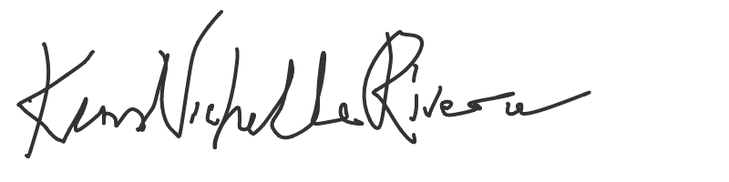
By: President

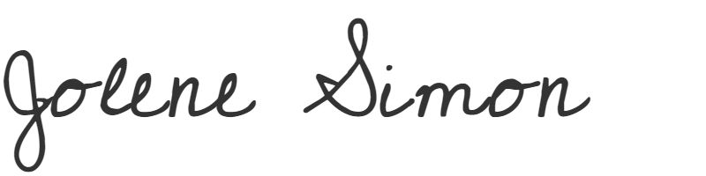
By:
Treasurer

